Volumes In Docker
- What are Volumes in docker?
A volume is Docker’s way to store data outside a container’s writable layer so that the data:
- Persists when a container stops or is removed, and
- Can be shared between containers or with the host.
Think of a volume like a persistent folder that containers can read/write to, but Docker manages where it lives on disk.

Why volumes exist (short)
Containers are ephemeral — when you delete a container, its writable layer is gone. Volumes let you keep important data (databases, uploads, logs) independent of the container lifecycle.

Types of Docker storage (quick overview)
- Named volumes (recommended for most use cases)
  - Managed by Docker. Easy to create and reuse.
  - Example name: mydata.
- Anonymous volumes
  - Created automatically if you use -v /data without a name. Harder to manage.
- Bind mounts
  - Maps a specific host directory into the container (e.g., /home/user/data:/app/data).
  - Useful for development (edit files on host and container sees changes).
- tmpfs mounts
  - Stored in memory (RAM). Fast but non-persistent. Good for sensitive or ephemeral data.
----------------------------------------------------------------------------------------------------------------------------------------------
Useful volume commands
- List volumes: docker volume ls
- Inspect volume (find mountpoint): docker volume inspect mydata
- Remove unused volumes: docker volume prune
- Remove a specific volume: docker volume rm mydata
----------------------------------------------------------------------------------------------------------------------------------------------
Where volume data lives
For named volumes Docker manages the storage (on Linux typically under /var/lib/docker/volumes/<volume>/_data). You usually don’t touch that directory directly — use Docker commands.

----------------------------------------------------------------------------------------------------------------------------------------------
Common use-cases
- Persisting database files (MySQL, Postgres).
- Saving uploaded files (user generated content).
- Sharing configuration or data between multiple containers (e.g., web + worker).
- Keeping logs for analysis outside the container.
----------------------------------------------------------------------------------------------------------------------------------------------
Best practices (short list)
- Use named volumes for app data in production.
- Use bind mounts for development and local code editing.
- Backup volumes regularly (databases!).
- Keep volume use minimal and documented in your Compose file or Docker commands.
----------------------------------------------------------------------------------------------------------------------------------------------
Real World Practical: -
Image: -
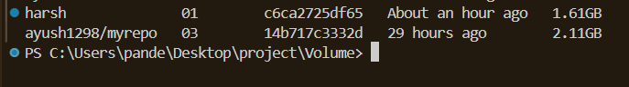

Remove old volume: -
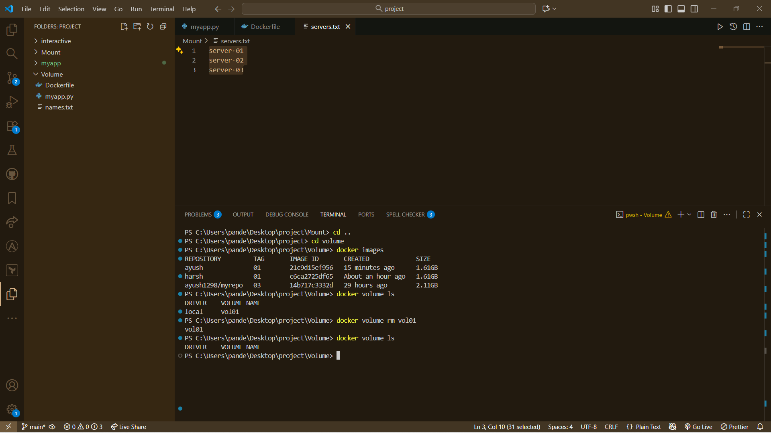

Now, Create a new volume with Existing volume: -
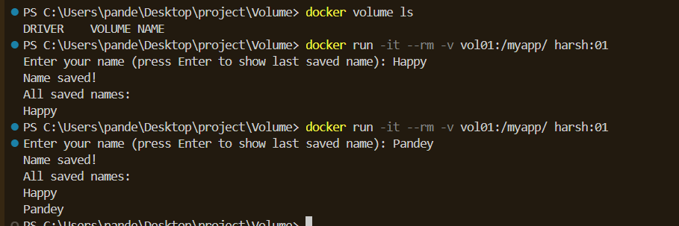
Command: - docker run -it --rm -v vol01:/myapp/ harsh:01

View In Docker Desktop: -
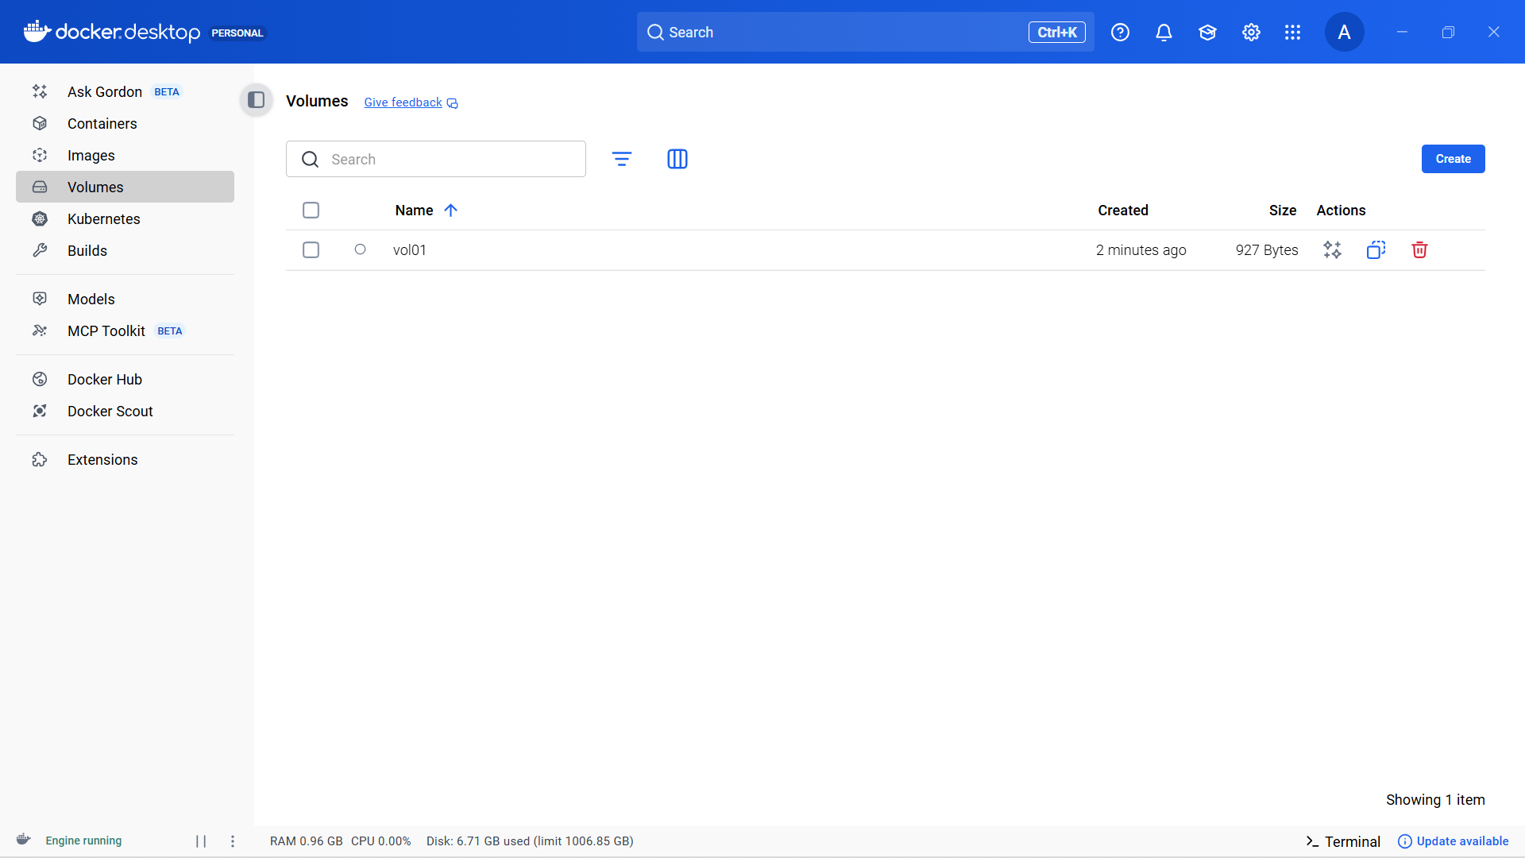

----------------------------------------------------------------------------------------------------------------------------------------------
Mount Binds In Docker

✅ What is a mount in Docker?
A mount means attaching a folder (storage) to a container so that the container can read/write data.
Think of it like plugging a USB drive into a computer — the container can use it, but the data stays safe outside the container.
Docker has different types of mounts:
- Volume mount (managed by Docker)
- Bind mount (folder from your host)
- tmpfs mount (RAM only)
----------------------------------------------------------------------------------------------------------------------------------------------
✅ What is a bind mount?
A bind mount means:
👉 You take a specific folder from your host machine
👉 And attach it to a folder inside the container.
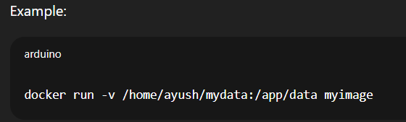
Meaning:
- Left (/home/ayush/mydata) → folder on your computer
- Right (/app/data) → folder inside the container
Anything you change on the host folder shows instantly inside the container — and vice-versa.
----------------------------------------------------------------------------------------------------------------------------------------------
🧠 Simple explanation (like real life)
Volume (Docker managed):
Like a storage box where Docker keeps your data.
Bind mount (host folder):
Like giving the container access to a specific folder on your laptop.
----------------------------------------------------------------------------------------------------------------------------------------------
🧪 When to use which?
✔ Bind mounts — Use for development
Because you can edit files on your PC and see changes inside the container immediately.
Example: Developing a Node or React app.
✔ Volumes — Use for production
Because Docker manages it safely, backups are easier, and no host directory issues.
Example: Database files (MySQL, Postgres).
----------------------------------------------------------------------------------------------------------------------------------------------
📝 Short and simple difference

Feature | Volume | Bind Mount
Managed by | Docker | You (host system)
Location | Docker folder | Your chosen folder
Good for | Production, DB | Development, live editing
Risk | Low | Higher (permissions, accidental deletes)

----------------------------------------------------------------------------------------------------------------------------------------------
Real World Practical: -
Image: -

- In the Output After running the container Servers.txt file is not updated
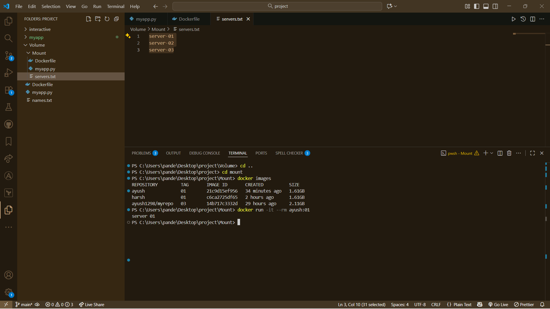

Now, See Final Touch-up after Mount Binding
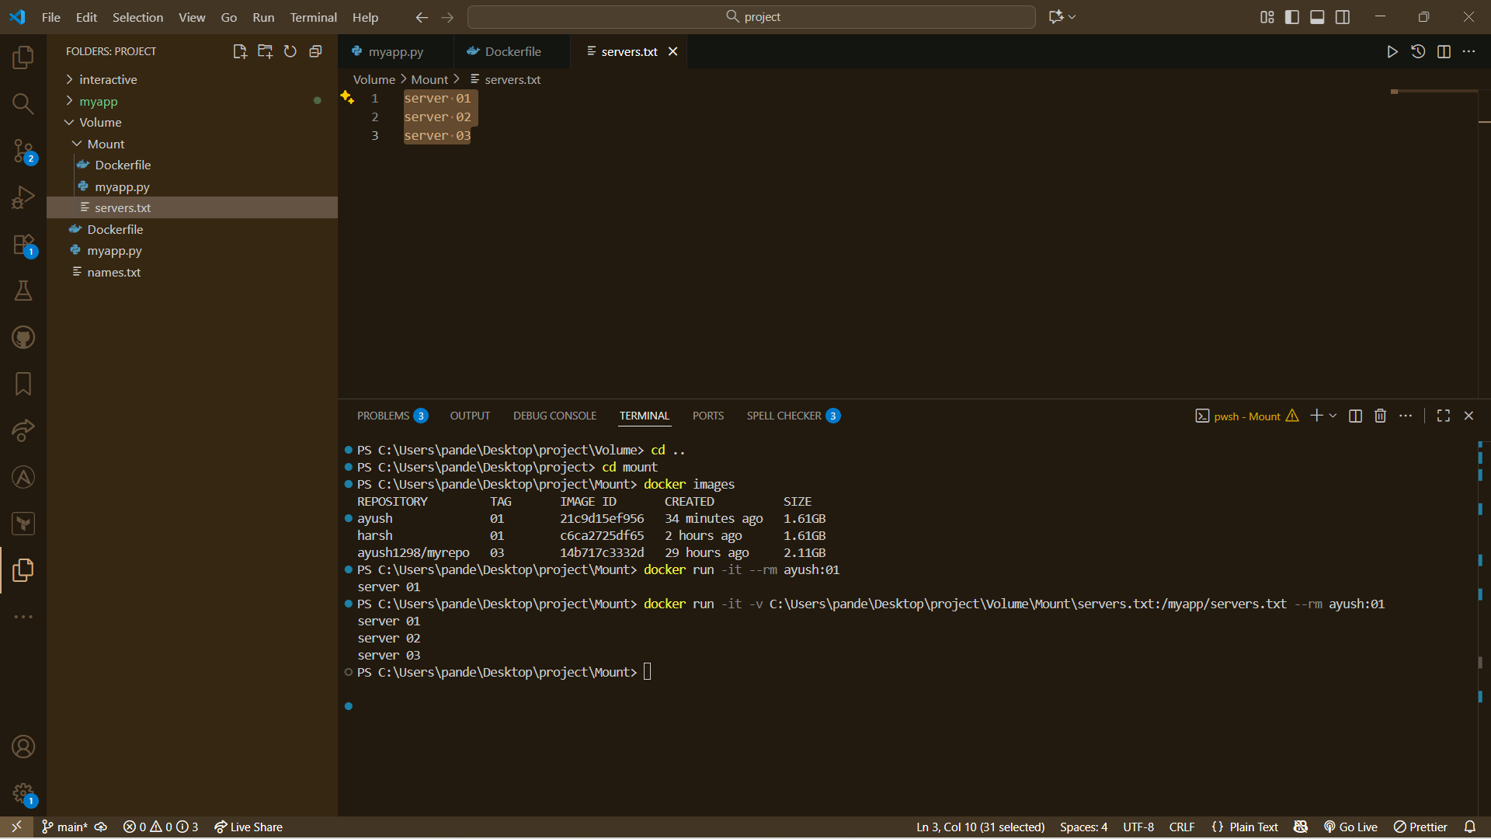
Command: - docker run -it -v C:\Users\pande\Desktop\project\Volume\Mount\servers.txt:/myapp/servers.txt --rm ayush:01

----------------------------------------------------------------------------------------------------------------------------------------------

